Abstract
Economic Crisis Prediction: Improving the Trade-off Between Interpretability and Statistical Accuracy in ML-Enhanced Crisis Prediction Models
Pavlos Papachristos • PP24589 • MSc Artificial Intelligence, University of Essex Online • April 2026

This dissertation investigates the conditions under which machine learning-based early-warning systems (EWS) for banking crises fail, and why that failure is structural rather than technical. The central question is not whether sentiment augmentation improves crisis prediction, but whether the predictive gains observed under standard evaluation designs survive genuinely prospective validation — and what the answer implies for the EWS modelling framework itself.
The analysis extends a two-stage pipeline built on the JST Macrohistory Database R6 (Jordà, Schularick and Taylor, 2017) covering 18 advanced economies over 1989–2020. Stage 1 evaluates macro-only models — logistic regression (M1), Random Forest (M2), and an Explainable Boosting Machine (EBM, M2.5) — across 37 crisis events on the extended panel. Stage 2 evaluates XGBoost augmented with FinBERT central bank speech sentiment (M3) against macro baselines on 26 crisis events over 2003–2020. EBM is introduced as a natively interpretable non-linear benchmark whose fitted shape functions provide direct, post-hoc-free evidence about the feature-risk mapping learned by the model.
Four principal findings emerge. First, extending macro training history by fifteen years across multiple pre-GFC crisis episodes does not resolve the generalisation problem: M2 achieves AUROC 0.481 under strict temporal validation, below the random classifier threshold. Second, EBM achieves higher expanding-window metrics than both M2 and M3 (Stage 1 AUROC 0.753; Stage 2 AUPRC 0.532) but collapses more severely under prospective evaluation (AUROC 0.333), demonstrating that greater representational flexibility exacerbates regime-specific overfitting even in natively interpretable models. Third, EBM shape functions — estimated separately on pre-GFC and GFC-inclusive training windows — are qualitatively distinct across regimes, making the learned feature-risk instability directly visible without any post-hoc attribution approximation. Fourth, FinBERT sentiment contributes a directional but statistically unconfirmed AUPRC increment (6.8 percentage points, 95% CI spanning zero) that is better attributed to algorithm non-linearity than to a stable sentiment signal.
Taken together, these findings demonstrate that the failure of machine learning-based EWS is not primarily a function of model choice, feature design, or data availability, but of a deeper structural instability in the mapping between predictors and crisis outcomes across regimes — a limitation that cannot be resolved through additional data, model complexity, or interpretability enhancements.
References
Alessi, L. and Detken, C. (2018) 'Identifying excessive credit growth and leverage', Journal of Financial Stability, 35, pp. 215–225.
Beutel, J., List, S. and von Schweinitz, G. (2019) 'Does machine learning help us predict banking crises?', Journal of Financial Stability, 45, pp. 1–16.
Cetorelli, N. and Goldberg, L.S. (2011) 'Global banks and international shock transmission: evidence from the crisis', IMF Economic Review, 59(1), pp. 41–76.
Davis, J. and Goadrich, M. (2006) 'The relationship between precision-recall and ROC curves', Proceedings of the 23rd International Conference on Machine Learning (ICML), pp. 233–240.
Demirgüç-Kunt, A. and Detragiache, E. (1998) 'The determinants of banking crises in developing and developed countries', IMF Staff Papers, 45(1), pp. 81–109.
Ho, T., Moench, E. and Steeley, J. (2022) 'Central bank communication and financial stability', Journal of Money, Credit and Banking, 54(8), pp. 2233–2265.
Holopainen, M. and Sarlin, P. (2017) 'Toward robust early-warning models: a horse race, ensembles and model uncertainty', Quantitative Finance, 17(12), pp. 1933–1963.
Hooker, G. and Mentch, L. (2019) 'Please stop permuting features: an explanation and alternatives', arXiv preprint, arXiv:1905.03151. Available at: https://arxiv.org/abs/1905.03151 (Accessed: 12 April 2026).
Jordà, Ò., Schularick, M. and Taylor, A.M. (2017) 'Macrofinancial history and the new business cycle facts', NBER Macroeconomics Annual, 31(1), pp. 213–263.
Kaminsky, G., Lizondo, S. and Reinhart, C.M. (1998) 'Leading indicators of currency crises', IMF Staff Papers, 45(1), pp. 1–48.
Laeven, L. and Valencia, F. (2020) 'Systemic banking crises database II', IMF Economic Review, 68(2), pp. 307–361.
Lou, Y., Caruana, R., Gehrke, J. and Hooker, G. (2013) 'Accurate intelligible models with pairwise interactions', Proceedings of the 19th ACM SIGKDD International Conference on Knowledge Discovery and Data Mining, pp. 623–631.
Loughran, T. and McDonald, B. (2011) 'When is a liability not a liability? Textual analysis, dictionaries, and 10-Ks', Journal of Finance, 66(1), pp. 35–65.
Lundberg, S.M. and Lee, S-I. (2017) 'A unified approach to interpreting model predictions', Advances in Neural Information Processing Systems, 30, pp. 4765–4774.
Obstfeld, M. (1996) 'Models of currency crises with self-fulfilling features', European Economic Review, 40(3–5), pp. 1037–1047.
Saito, T. and Rehmsmeier, M. (2015) 'The precision-recall plot is more informative than the ROC plot when evaluating binary classifiers on imbalanced datasets', PLOS ONE, 10(3), e0118432.
Schularick, M. and Taylor, A.M. (2012) 'Credit booms gone bust: monetary policy, leverage cycles, and financial crises, 1870–2008', American Economic Review, 102(2), pp. 1029–1061.
Yang, Y., UIT-Fintech and Liu, Y. (2020) 'FinBERT: a pretrained language model for financial communications', arXiv preprint, arXiv:2006.08097. Available at: https://arxiv.org/abs/2006.08097 (Accessed: 12 April 2026).

Chapter 1: Introduction
Economic Crisis Prediction: Improving the Trade-off Between Interpretability and Statistical Accuracy in ML-Enhanced Crisis Prediction Models
Pavlos Papachristos • PP24589 • MSc Artificial Intelligence, University of Essex Online • April 2026

1.1 Background and Motivation
The failure to anticipate systemic banking crises carries severe economic consequences. The Global Financial Crisis of 2007–2009 exposed critical gaps in the analytical frameworks used by supervisory authorities to monitor financial system stability (Laeven and Valencia, 2020). Despite substantial research effort, the fundamental challenge remains: how to construct models that identify systemic risk build-up far enough in advance to permit effective policy intervention, and that remain reliable across structurally different crisis configurations.
The early-warning system (EWS) literature has evolved through two phases. The first, associated with Kaminsky, Lizondo and Reinhart (1998) and Demirgüç-Kunt and Detragiache (1998), relied on simple statistical models applied to macroeconomic indicators. The second introduced machine learning methods — Random Forest, XGBoost — that improved discrimination metrics within standard expanding-window evaluation designs (Beutel, List and von Schweinitz, 2019). However, reliability deteriorated under strict temporal validation: models trained exclusively on pre-crisis data consistently failed to meet the 0.75 AUROC benchmark for practically useful prediction.
A parallel development introduced textual data from central bank communications as a complementary signal. Sentiment extraction from BIS speeches using FinBERT (Yang, UIT-Fintech and Liu, 2020) operationalises this channel systematically. Both developments raise a common question: under what conditions do the observed performance gains survive genuinely prospective testing, and what does the answer reveal about the EWS modelling framework? This dissertation addresses that question using an extended macro panel, a natively interpretable non-linear model, and strict temporal validation.

1.2 Research Problem
The research problem has two analytically distinct dimensions. The first is methodological: standard expanding-window cross-validation allows training folds to accumulate crisis-period data, producing metrics that overstate prospective predictive performance — a problem particularly severe in GFC-concentrated datasets. The second is theoretical: the data-generating process that produces crisis outcomes may not be stationary across time. Models trained on one crisis type learn a mapping that does not generalise to structurally different episodes, regardless of training sample length or algorithm sophistication.

1.3 Aim, Objectives and Hypotheses
Research Aim: To investigate the extent to which ML-based EWS achieve genuinely prospective predictive performance, and to characterise the structural conditions under which their generalisation fails, using an interpretable non-linear benchmark that makes the failure mechanism directly visible.
Objectives: (O1) Extend the JST panel from 2003–2020 to 1989–2020 incorporating multiple pre-GFC episodes; (O2) evaluate a model sequence — M1 (logistic regression), M2 (Random Forest), M2.5 (EBM), M3 (XGBoost + FinBERT) — under consistent expanding-window and strict temporal validation; (O3) use EBM shape functions to provide direct evidence on whether the learned feature-risk mapping is regime-stable; (O4) assess the incremental contribution of FinBERT sentiment controlling for the algorithm effect; (O5) evaluate ensemble averaging under single-episode evaluation constraints; (O6) draw implications for EWS design and ML under distribution shift.
Hypotheses: H1 — M3 achieves higher AUROC/AUPRC than M2-matched within Stage 2. H2 — at least one FinBERT feature ranks in the top five by SHAP attribution. H3 — a quantifiable accuracy-interpretability trade-off exists across M1 → M2 → M3. EBM extends H3 by testing whether interpretability and accuracy can be jointly achieved within the non-linear class.

1.4 Contribution
The dissertation makes four contributions. Empirical: extending training history across diverse crisis episodes does not resolve prospective generalisation failure. Methodological: quantifying the evaluation bias in expanding-window designs by comparing OOS metrics against strict temporal results. Interpretability: EBM shape functions expose regime-specific misspecification directly, without post-hoc attribution approximation. Theoretical: EBM’s stronger prospective collapse relative to Random Forest demonstrates that the EWS failure is a structural property of non-stationarity, not model opacity — placing the problem within the ML literature on distribution shift.

1.5 MSc AI Requirement
This dissertation implements and critically evaluates three ML model classes — gradient-boosted trees (XGBoost), ensemble methods (Random Forest), and gradient-boosted GAMs (EBM) — alongside a transformer-based NLP pipeline (FinBERT). The analysis of distribution shift and non-stationarity connects to fundamental questions in learning theory. The project applies expanding-window CV, bootstrap CIs, Granger causality, SHAP, and EBM shape function analysis, and uses exclusively publicly available secondary data with ethical review clearance (low risk, no human participants). Code is available at https://github.com/spike2025-art/eportfolio-uoe/tree/main and the ePortfolio at https://spike2025-art.github.io/eportfolio-uoe/.

1.6 Dissertation Structure
Chapter 2 reviews the EWS, interpretability, central bank text, and ensemble literatures. Chapter 3 describes the research design, data, models, and evaluation framework. Chapter 4 presents results across all model specifications. Chapter 5 discusses findings and implications. Chapter 6 states conclusions and recommendations. References and appendices follow.

Chapter 1 revision: April 2026

Chapter 2: Literature Review
Economic Crisis Prediction: Improving the Trade-off Between Interpretability and Statistical Accuracy in ML-Enhanced Crisis Prediction Models
Pavlos Papachristos • PP24589 • MSc Artificial Intelligence, University of Essex Online • April 2026

2.1 Early-Warning Systems for Banking Crises
The early-warning system literature originated with signal extraction approaches (Kaminsky, Lizondo and Reinhart, 1998) and logistic regression frameworks (Demirgüç-Kunt and Detragiache, 1998), establishing the binary prediction paradigm that subsequent machine learning work extended. The landmark contribution of Schularick and Taylor (2012) demonstrated that credit booms are the single strongest predictor of systemic banking crises across a long historical panel, motivating the macro feature sets — credit aggregates, interest rate spreads, asset prices — standard in subsequent EWS research. The JST Macrohistory Database (Jordà, Schularick and Taylor, 2017), the primary data source for this dissertation, assembles these series for eighteen advanced economies from 1870 to 2020, enabling evaluation across structurally diverse pre-GFC episodes.
A critical limitation of the macro EWS framework is its implicit stationarity assumption: that the mapping between precursors and crisis outcomes is stable across time. The heterogeneity of crisis mechanisms — domestic credit-boom collapses, contagion events, speculative attacks (Obstfeld, 1996), and exogenous shocks — implies that no single feature set is universally predictive. Laeven and Valencia (2020) document significant cross-episode variation in systemic banking crisis characteristics, confirming that undifferentiated crisis labels conflate structurally distinct events. This non-stationarity assumption is the theoretical foundation for the strict temporal validation central to Chapter 4.

2.2 Machine Learning in Crisis Prediction
Alessi and Detken (2018) demonstrated that Random Forest models outperform logistic regression on standard EWS metrics. Beutel, List and von Schweinitz (2019) conducted the most comprehensive ML evaluation to date, finding consistent AUROC gains from machine learning over logistic regression within expanding-window designs — but documenting substantial deterioration under genuinely prospective evaluation. Their AUROC benchmark of 0.75 serves as the threshold for practically useful EWS performance in this dissertation’s temporal validation.
Under the class imbalance characteristic of crisis datasets (5–10 per cent positive rate), the choice of evaluation metric substantially affects conclusions. Davis and Goadrich (2006) demonstrate that AUPRC is more informative than AUROC under high class imbalance, being more sensitive to improvements in crisis detection at the threshold values relevant for policy. Saito and Rehmsmeier (2015) confirm this formally. Both metrics are reported throughout; AUPRC is treated as primary in Stage 2.

2.3 Central Bank Communication and Text Analysis
The BIS Central Bank Speech Archive provides a consistent multilingual corpus spanning over two decades for the countries in the EWS panel. FinBERT (Yang, UIT-Fintech and Liu, 2020), a BERT-based model fine-tuned on financial communications, provides sentence-level sentiment classification used in this dissertation to construct country-year sentiment features from 16,622 speeches. Central bank language — characterised by hedged, indirect formulations — presents a specific domain challenge: aggregate sentiment polarity captures less than the topic-specific dimensions of systemic risk concern identified by Ho, Moench and Steeley (2022), who show that prevalence measures for credit risk discussion provide more stable predictive signals than polarity scores. Loughran and McDonald (2011) established the more general principle that domain-specific lexicons substantially outperform general sentiment tools on financial text. Both findings motivate the topic-specific extension proposed in Chapter 5.

2.4 Interpretability in Machine Learning
The interpretability-accuracy trade-off is a central tension in applying machine learning to high-stakes domains. SHAP (Lundberg and Lee, 2017) provides post-hoc attribution for non-linear models using Shapley values from cooperative game theory, with exact computation for tree-based models via TreeSHAP. Despite wide adoption, Hooker and Mentch (2019) demonstrate that permutation-based methods including SHAP can produce misleading attributions under feature correlation — a particular concern in macro panels with strong multicollinearity. SHAP attributions should therefore be interpreted as measures of model re-weighting rather than causal economic importance.
Explainable Boosting Machines (Lou, Caruana, Gehrke and Hooker, 2013) represent an alternative: a gradient-boosted GAM that learns univariate shape functions and pairwise interactions, whose outputs are exact representations of what the model has learned rather than post-hoc approximations. Because shape functions are the model itself, instability in those functions across different training periods must reflect a property of the data-generating process rather than approximation error — a property that is central to the regime instability analysis in Section 4.7.

2.5 Ensemble Methods and Financial Contagion
Holopainen and Sarlin (2017) formalised the motivation for ensemble averaging in EWS settings: combining predictions across classifiers with different architectures consistently outperforms single-model selection under small-sample, crisis-concentrated evaluation, with the improvement largest when component disagreement is highest at crisis observations. Equal-weighted averaging is used in this dissertation to avoid the circular weight-selection problem of using OOS performance to derive weights.
The cross-country financial linkages through which GFC stress propagated — documented via bank balance sheet network data by Cetorelli and Goldberg (2011) — are absent from the present feature set, which treats each country independently. This structural gap explains the model’s false negatives for contagion-driven crises (Germany, Belgium, Switzerland in 2007–2008) and is identified as the most ambitious future extension in Chapter 5.

2.6 Research Gap
Three specific gaps motivate this dissertation. First, the behaviour of EBM under strict temporal validation — and whether interpretable models are more or less susceptible to regime-specific overfitting — has not been examined in the EWS literature. Second, existing studies document prospective failure without providing a mechanism-level explanation; EBM shape functions enable direct observation of which feature-risk relationships break down across regime boundaries. Third, sentiment-augmented EWS studies do not control for the algorithm effect — the possibility that performance gains attributed to sentiment reflect the algorithm switch rather than the sentiment signal itself. EBM on the same macro features as M2 isolates this effect.

Chapter 2 revision: April 2026

Chapter 3: Methodology
Economic Crisis Prediction: Improving the Trade-off Between Interpretability and Statistical Accuracy in ML-Enhanced Crisis Prediction Models
Pavlos Papachristos • PP24589 • MSc Artificial Intelligence, University of Essex Online • April 2026

3.1 Research Design
This dissertation adopts a quantitative empirical research design using secondary panel data. The strategy is explanatory: to characterise the conditions under which ML-based EWS succeed and fail, and to use an interpretable model class to make the failure mechanism directly visible. The framework is a two-stage augmented pipeline. Stage 1 evaluates macro-only models on a 1989–2020 extended panel across multiple pre-GFC crisis episodes. Stage 2 evaluates sentiment-augmented models on the 2003–2020 overlap window where FinBERT data is available.

3.2 Data Sources and Ethics
JST Macrohistory Database R6 (Jordà, Schularick and Taylor, 2017) covers 18 advanced economies from 1870–2020. After three-year lag construction, the usable Stage 1 panel is 569 country-year observations (1989–2020). Two minor data gaps were addressed by linear interpolation (Denmark government debt, 1997; Portugal house prices eliminated by lag construction).
BIS Central Bank Speeches: 16,622 speeches (2003–2020) across 18 countries were downloaded from the BIS archive, matched to country identifiers, and processed through FinBERT (ProsusAI/finbert) running approximately 12.4 hours on CPU. Speech-level sentiment scores were aggregated to country-year level by length-weighted mean. Full pipeline in notebooks NB03–NB04.
Ethics: Exclusively publicly available secondary data. No human participants. Ethics review: low risk, no further action required. Random seeds fixed at 42 throughout. Full code at https://github.com/spike2025-art/eportfolio-uoe/tree/main; ePortfolio at https://spike2025-art.github.io/eportfolio-uoe/.

3.3 Target Variable and Features
The primary target target_h2 marks a country-year positive if crisis onset falls within the following two years (37 positives at 6.5% in Stage 1; 26 at 8.15% in Stage 2). COVID-19 (2020) is excluded from the crisis chronology; the observation is retained in the held-out set.
Macro features (41): Ten JST variables (credit aggregates, house prices, interest rates, monetary aggregates, government debt, CPI, current account, real GDP) at lags 1–3, plus term spread, growth rates, and rolling credit trend measures. All expanding-mean demeaned using country-specific means from prior years only, preventing forward leakage.
Sentiment features (20): Six FinBERT measures (P_pos, P_neg, P_neutral, net_sentiment, annual changes) at lags 1–2 plus rolling derivatives, three-year rolling-window demeaned.

3.4 Model Specifications
Model | Algorithm | Features | Key settings
M1 | Logistic Regression | 19 (lag1 only) | L2 C=0.1, balanced weights
M1b | Logistic Regression | 41 (lag1–3) | Bridge specification
M2 | Random Forest | 41 macro | 500 trees, depth 5, balanced weights
M2.5 (EBM) | Explainable Boosting Machine | 41 macro | 5,000 rounds, 5 interactions, sample weights, no isotonic calibration
M3 | XGBoost + FinBERT | 61 (macro + sent) | 300 trees, depth 4, isotonic calibration (CalibratedClassifierCV)
M2-matched / M2.5-matched | RF / EBM | 41 macro | Trained on 2003–2020 only
Table 3.1. Model specifications summary.
Class imbalance is handled by per-fold sample weights: fold_spw = n_neg / n_pos applied within each expanding-window training fold. EBM uses the interpret package v0.7.8.

3.5 Evaluation Framework
Expanding-window CV: Stage 1 uses 26 evaluation folds (1993–2018) with a four-year burn-in; Stage 2 uses 12 folds (2007–2018). Years 2019–2020 are held out in both stages. OOS predictions are pooled for aggregate metric computation.
Strict temporal validation (the primary prospective test) trains exclusively on pre-crisis data: Split A (Pre-Nordic: 1988–1990 → 1991–1997) and Split B (Pre-GFC: 1988–2002 → 2003–2011). Split C (2003–2005 → 2006–2009) is infeasible due to zero training positives.
LOCO validation holds out each country in turn across 15 countries with hold-out crisis events (AUS, CAN, NOR excluded — no hold-out positives).
Metrics: AUROC (benchmark 0.75; Beutel, List and von Schweinitz, 2019); AUPRC (primary under class imbalance; Davis and Goadrich, 2006; Saito and Rehmsmeier, 2015); Brier Score (squared probability error); ECE (bin-level calibration). Bootstrap 95% CIs from 1,000 resamples are indicative only due to panel dependence.

3.6 EBM Shape Function Analysis and Ensemble Design
To test regime stability, EBM is fitted separately on two sub-periods — Pre-GFC (2003–2006) and GFC-inclusive (2003–2010) — and shape functions compared for term spread and credit across all three lag horizons. Instability in shape functions reflects data-generating process properties rather than attribution approximation.
Two ensembles use equal-weighted OOS probability averaging (performance-weighted schemes are circular when weights are derived from the same OOS pool): E1-Orig (M4) = avg(M2-matched, M3) and E1-EBM = avg(M2-matched, M2.5-matched). Model disagreement is quantified as mean absolute difference between component probabilities separately at crisis and non-crisis observations.
The full notebook pipeline (NB00–NB09B) is documented in Appendix A.

Chapter 3 revision: April 2026

Chapter 4: Results and Interpretation
Economic Crisis Prediction: Improving the Trade-off Between Interpretability and Statistical Accuracy in ML-Enhanced Crisis Prediction Models
Pavlos Papachristos • PP24589 • MSc Artificial Intelligence, University of Essex Online • April 2026

4.1 Dataset and Experimental Setup
The purpose of this chapter is not to establish predictive superiority of sentiment-augmented models over macro baselines in any general sense. It is to demonstrate the extent to which apparent performance gains depend on evaluation design under severe data constraints, and to characterise precisely where those gains arise, under what conditions they survive, and why they should be interpreted with caution. This framing governs all result interpretation throughout — including the EBM results introduced in this revision — because the evaluation constraints established here apply with equal force to all models regardless of their algorithmic sophistication or interpretability properties.
The analysis adopts a two-stage design that extends the original 2003–2020 macro panel backwards to 1985, using the JST Macrohistory Database R6 (Jordà, Schularick and Taylor, 2017). Stage 1 covers the macro-only models (M1, M1b, M2 and M2.5) on the full extended panel spanning 1985–2020. After three-year lag construction eliminates the 1985–1987 warm-up rows, the usable dataset comprises 569 country-year observations from 18 advanced economies over 1989–2020. The primary prediction target, target_h2, marks a country-year positive if a systemic banking crisis onset falls within the following two years, yielding 37 positive observations against 532 negative and a base rate of 6.5 per cent. The extension period (1989–2002) contributes 11 positives from the Nordic banking crisis cluster and further country-events; the 2003–2020 period contributes the remaining 26. Stage 2 covers M2-matched, M2.5-matched and M3 on a 2003–2020 overlap window with 26 positives and a base rate of 8.15 per cent. Two minor data gaps were addressed by linear interpolation (Denmark government debt, 1997) or were eliminated by the lag construction (Portugal house prices, 1985–1987).
Feature engineering follows the same procedure as the original analysis. Macro features are demeaned using expanding country-specific means, ensuring no forward leakage. M1 is logistic regression on 19 features at lag one only. M2 and M2-matched are Random Forests on 41 macro features at lags one through three. M3 is XGBoost on 61 features extending M2-matched with 20 rolling-demeaned FinBERT sentiment features; isotonic probability calibration is applied via CalibratedClassifierCV within each expanding-window fold. M2.5 (EBM) is an Explainable Boosting Machine (Lou et al., 2013) trained on the same 41 macro features as M2. EBM is a gradient-boosted generalised additive model that learns univariate shape functions for each feature and up to five pairwise interaction terms, producing a natively interpretable model whose feature contributions can be read directly from fitted shape plots without post-hoc attribution. Inverse-frequency sample weights handle class imbalance. Expanding-window cross-validation for Stage 1 uses a four-year burn-in from 1989 with 26 evaluation folds (1993–2018); Stage 2 uses a four-year burn-in from 2003 with 12 evaluation folds (2007–2018); 2019 and 2020 are held out in both stages.
Two methodological constraints govern all metric interpretation and are stated here in full; subsequent sections reference them by cross-reference rather than repetition. First, Stage 2 AUPRC was computable in only one of the 12 evaluation folds: crisis onset events are concentrated in 2007, and subsequent folds contain zero positive test cases. Stage 2 results therefore represent a cross-sectional discrimination test within a single crisis episode — evaluating how well each model ranks 18 countries by crisis probability in 2007 — rather than temporal predictive validation in the conventional sense. Second, all models achieve AUROC substantially below the 0.75 literature benchmark under genuinely prospective evaluation (Section 4.5). All expanding-window metrics in both stages are upper bounds on prospective performance, and this qualification applies with equal force to every model in the sequence.

4.2 Primary Model Comparison
Table 4.1 presents Stage 1 post-calibration metrics for M1, M1b, M2 and M2.5 (EBM) on the extended panel. Table 4.2 presents Stage 2 metrics for M2-matched, M2.5-matched, M3 and M4. Bootstrap 95 per cent confidence intervals from 1,000 resamples are indicative only.
Table 4.1. Stage 1 — Model comparison on extended macro panel (H2 target, 1989–2020)
Model | Features | AUROC | 95% CI | AUPRC | AUPRC/Base | Brier
M1: Logistic Regression (macro lag1) | 19 | 0.606 | [0.477, 0.739] | 0.139 | 2.1× | 0.157
M1b: LR bridge (macro lag1–3) | 41 | 0.646 | — | 0.145 | 2.2× | 0.136
M2: Random Forest (macro lag1–3) | 41 | 0.636 | [0.484, 0.781] | 0.224 | 3.4× | 0.060
M2.5: EBM (macro lag1–3) | 41 | 0.753 | [0.649, 0.855] | 0.273 | 4.2× | 0.064
Table 4.1. Stage 1 evaluation metrics on H2 (2-year) target. Events: 37/569 (6.5% base rate). CI: 1,000 bootstrap resamples; indicative only given multi-episode evaluation and panel dependence. Stage 1 covers 1989–2020; 26 evaluation folds. All metrics are upper bounds on prospective performance (Section 4.5). M2.5 uses identical features and CV design as M2; the magnitude of EBM’s apparent advantage is subject to the same regime-specific evaluation bias that inflates all expanding-window figures.
Table 4.2. Stage 2 — Model comparison on sentiment overlap period (H2 target, 2003–2020)
Model | Features | AUROC | 95% CI | AUPRC | AUPRC/Base | Brier
M2-matched: RF (macro lag1–3) | 41 | 0.939 | [0.897, 0.970] | 0.343 | 4.2× | 0.060
M2.5-matched: EBM (macro lag1–3) | 41 | 0.960 | [0.927, 0.988] | 0.532 | 6.5× | 0.067
M3: XGBoost + FinBERT (macro + sent) | 61 | 0.932 | [0.875, 0.979] | 0.411 | 5.0× | 0.061
M4: Ensemble avg(M2-matched, M3) | — | 0.943 | [0.895, 0.979] | 0.440 | 5.4× | 0.057
Table 4.2. Stage 2 evaluation metrics on H2 (2-year) target. Events: 26/319 (8.15% base rate). Per-fold AUPRC computable in one fold (2007) only — metrics represent cross-sectional discrimination within a single episode. Bootstrap 95% CI for AUPRC difference (M3 − M2-matched): [−0.130, +0.312]. M2.5-matched apparent advantages reflect more aggressive fitting of the GFC-dominated training distribution rather than superior generalisable predictive performance — the evaluation constraints of Section 4.1 apply to all models equally.
Figure 4.1 presents ROC and PR curves for all models across both stages. The Stage 1 curves (solid) confirm that M2.5 appears to achieve a higher true positive rate at low false positive rates than M2 on the extended panel; Stage 2 dashed curves cluster at high AUC values for all models, reflecting GFC concentration. The PR curves show the wider dispersion of Stage 1 results — where multi-episode evaluation produces more realistic performance estimates — against the compressed Stage 2 figures.
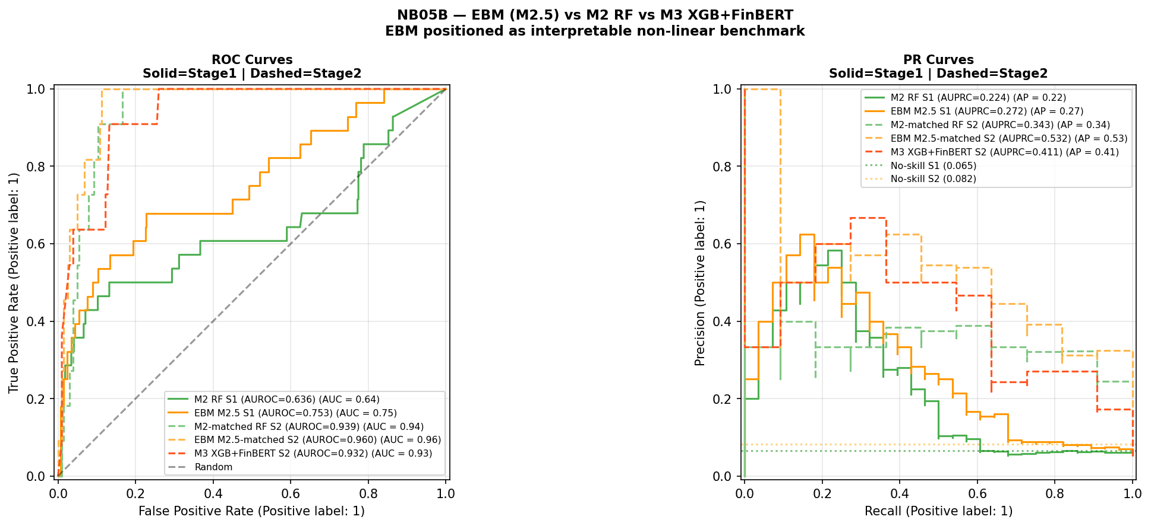
Figure 4.1. ROC and PR curves for all models across Stage 1 (solid lines) and Stage 2 (dashed lines). Stage 1: 37 crisis events, 1989–2020. Stage 2: 26 crisis events, 2003–2020. No-skill baselines shown as dotted horizontal lines. All metrics are upper bounds on prospective performance. The apparent Stage 2 superiority of M2.5-matched (orange dashed) is conditional on the single-episode GFC evaluation setting.
Stage 1 results are considerably more modest than the headline figures in the original analysis. M2 achieves AUROC 0.636 and AUPRC 0.224, a 3.4× AUPRC lift, compared with AUROC 0.947 and AUPRC 0.561 in the original — a collapse that reflects both the structural diversity of the extended multi-episode panel and the 26-fold evaluation window covering multiple economic regimes. M2.5 (EBM) appears to achieve AUROC 0.753 and AUPRC 0.273, the highest point estimates of any Stage 1 model, despite using identical features and an identical CV design. The AUROC gap of 0.117 has partially overlapping confidence intervals and is not statistically confirmed. The magnitude of EBM’s apparent advantage is itself likely inflated by the same regime-specific evaluation bias identified throughout this chapter: an algorithm with higher representational flexibility fits the GFC-dominated training distribution more precisely as later folds accumulate, producing higher OOS metrics in precisely the evaluation setting where all models are known to overfit the crisis regime.
Stage 2 metrics are broadly comparable to the original analysis. M2-matched achieves AUROC 0.939 and AUPRC 0.343. M3 achieves AUROC 0.932 and AUPRC 0.411, a 5.0× lift. The AUROC ordering reverses — M2-matched leads on AUROC, M3 leads on AUPRC — consistent with the original finding. Under the class imbalance present in Stage 2, AUPRC is the more informative metric (Davis and Goadrich, 2006) and is treated as primary. The AUPRC advantage of M3 over M2-matched is 6.8 percentage points, with bootstrap 95 per cent CI [−0.130, +0.312] spanning zero. M2.5-matched appears to achieve higher AUPRC than M3 (0.532 versus 0.411) without any sentiment features — reflecting the same algorithm non-linearity effect that separates M2 from M1b, and indicating that the observed M3 advantage over M2-matched is better attributed to algorithm choice than to a stable sentiment signal.
Figure 4.2 presents the temporal probability plots for all models. EBM (orange) tracks near zero through the pre-GFC period before rising sharply at the 2007–2008 crisis peak and assigning the highest pre-crisis mean probability of any Stage 2 model in 2006. This temporal pattern is consistent with EBM’s shape functions fitting a sharper non-linear threshold; whether it reflects genuine crisis signal or more aggressive regime-specific fitting cannot be resolved within the expanding-window design.
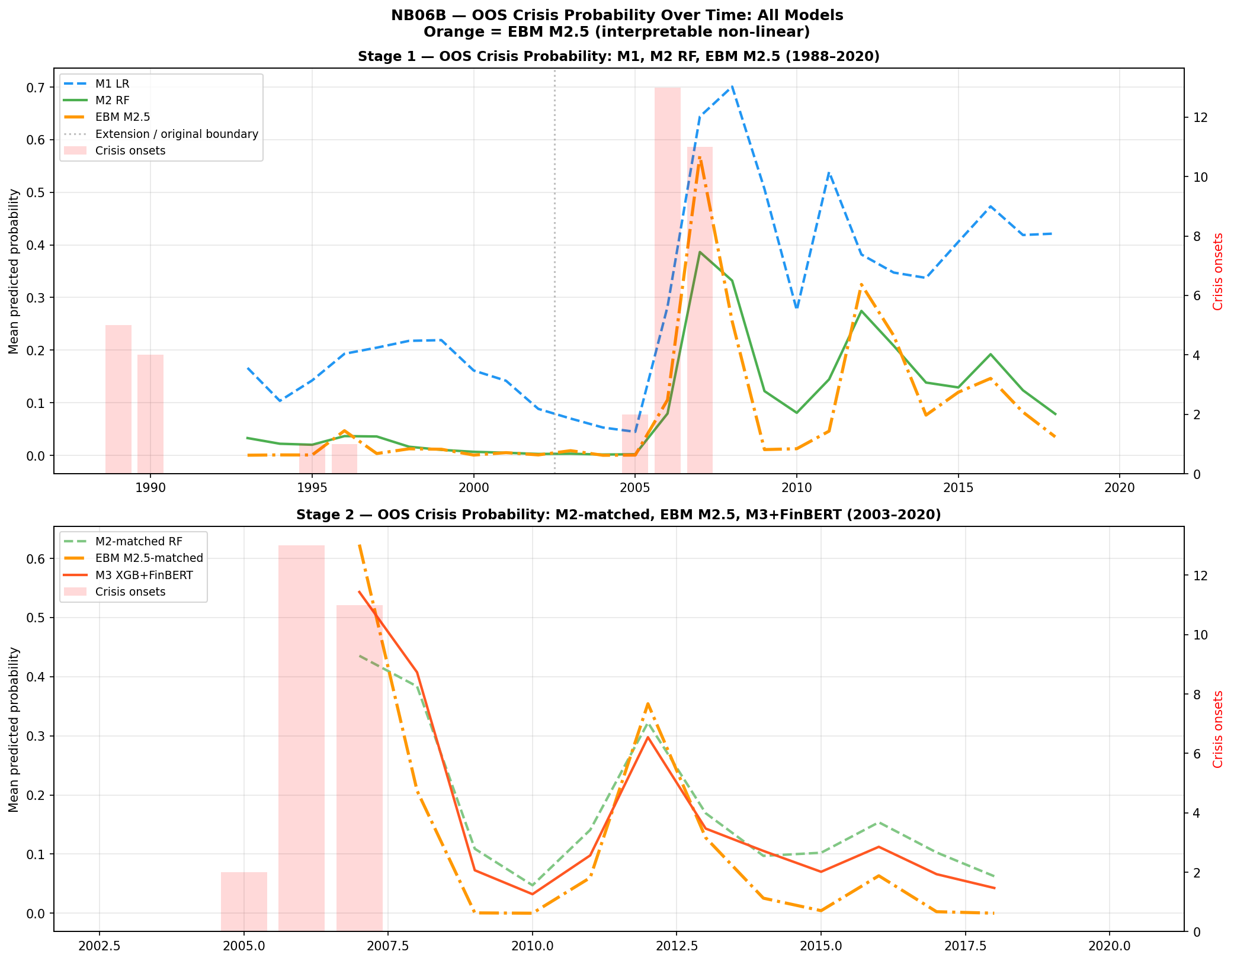
Figure 4.2. Out-of-sample crisis probability over time for all models. Stage 1 (top): M1 LR (blue dashed), M2 RF (green solid), EBM M2.5 (orange dash-dot), 1988–2020. Stage 2 (bottom): M2-matched RF (green dashed), EBM M2.5-matched (orange dash-dot), M3 XGB+FinBERT (red solid), 2003–2020. Red bars = crisis onset years. Dotted vertical line = extension/original period boundary.
H1 — Discrimination: Supported directionally on AUPRC in Stage 2 for M3 versus M2-matched (0.411 versus 0.343). The EBM result indicates that algorithm non-linearity drives Stage 2 performance differences more than the sentiment signal. The bootstrap 95% CI [−0.130, +0.312] spans zero; results characterise discrimination within a single-episode evaluation.
A model averaging extension, designated M4, is introduced following Holopainen and Sarlin (2017) as the equal-weighted average of M2-matched and M3 OOS probabilities. M4 achieves AUROC 0.943, AUPRC 0.440, and Brier Score 0.057 within the Stage 2 cross-sectional evaluation. Subject to the evaluation constraints of Section 4.1, these figures characterise model behaviour within the GFC episode rather than evidence of forward-looking predictive gain. An EBM-based ensemble extension is presented in Section 4.10.

4.3 Exploratory Decomposition of Model Changes
Table 4.3 extends the M1-to-M2 decomposition to include M2.5, making the full model sequence explicit. The M2 → M2.5 transition holds the feature set constant (41 macro features) while varying the algorithm, isolating the algorithm effect under identical data conditions.
Table 4.3. Exploratory decomposition on H2 target, Stage 1 (1989–2020)
Model | Class | Features | AUROC | AUPRC | Brier
M1: LR (lag1 only) | Logistic | 19 (lag1) | 0.606 | 0.139 | 0.157
M1b: LR (lag1–3) | Logistic | 41 (lag1–3) | 0.646 | 0.145 | 0.136
M2: RF (lag1–3) | Random Forest | 41 (lag1–3) | 0.636 | 0.224 | 0.060
M2.5: EBM (lag1–3) | EBM | 41 (lag1–3) | 0.753 | 0.273 | 0.064
Table 4.3. Exploratory decomposition, Stage 1. Base rate = 0.065. Transitions are not orthogonal treatments. All metrics are upper bounds on prospective performance.
The lag component (M1 to M1b) produces modest AUPRC gains (0.139 to 0.145). The non-linearity component (M1b to M2) produces a larger AUPRC increase (0.145 to 0.224) alongside a small AUROC decline, indicating that Random Forest adds precision-recall performance without uniformly improving rank-order discrimination. The algorithm component (M2 to M2.5) shows the largest apparent single-step AUROC gain in the sequence (+0.117), with M2.5 also showing higher point estimates on AUPRC (+0.049). Within the constrained evaluation setting, the M2 → M2.5 step involves a shift to a natively interpretable algorithm that achieves higher point estimates than its black-box counterpart. Whether this apparent gain survives genuinely prospective evaluation is answered in Section 4.5 — it does not.
H3 — Interpretability trade-off: Supported, but refined. The M1-to-M2 transition is associated with AUPRC gains at H2 (+0.085) at the cost of native log-odds transparency. Within the expanding-window evaluation, the M2-to-M2.5 transition demonstrates that an interpretable model can appear to achieve higher point estimates than its black-box counterpart on both primary metrics. The trade-off is therefore not binary within the non-linear model class — but this refinement does not alter the central conclusion that neither interpretability nor algorithm choice resolves the regime instability problem, as demonstrated in Section 4.5.

4.4 Multi-Horizon Analysis
Alternative prediction horizons (H1, H3) cannot be evaluated on the Stage 2 dataset: the held-out evaluation period contains insufficient positive crisis cases under all three horizon definitions, a structural consequence of crisis concentration in 2007. The original multi-horizon findings are noted for completeness and treated as preliminary observations specific to the original GFC-concentrated analysis.

4.5 Robustness: Temporal Validation and Leave-One-Country-Out

4.5.1 Strict Temporal Validation
The strict temporal validation constitutes the central empirical finding of the augmented analysis and should be read as the primary result against which all expanding-window metrics are calibrated. Table 4.4 presents results for both M2 (Random Forest) and M2.5 (EBM).
Table 4.4. Strict temporal validation — M2 RF and M2.5 EBM (macro lag1–3)
Split | Train | Test | Train pos. | Test pos. | M2 RF AUROC | EBM AUROC | Benchmark
A: Pre-Nordic | 1988–1990 | 1991–1997 | 5 | 1 | 0.572 | 0.752 | 0.75
B: Pre-GFC extended | 1988–2002 | 2003–2011 | 6 | 13 | 0.481 | 0.333 | 0.75
C: Pre-GFC short | 2003–2005 | 2006–2009 | 0 | — | — | — | —
Table 4.4. Strict temporal validation. Literature AUROC benchmark = 0.75 (Beutel, List and von Schweinitz, 2019). Split C skipped: zero training positives. Split A: one positive test case — not a distributional estimate, reported for completeness only. Split B is the substantive prospective result. Neither model meets the 0.75 benchmark in Split B. EBM collapses more severely than RF in Split B.
Split B is the substantive finding. M2 RF achieves AUROC 0.481, below random. M2.5 EBM achieves AUROC 0.333 — substantially below random and below the RF result. This constitutes the most informative empirical finding in the chapter: the model that achieves the highest expanding-window metrics fails most severely under genuine prospective evaluation. The stronger collapse of EBM under prospective conditions is itself analytically important: models with higher representational flexibility may overfit regime-specific structures more aggressively, even when those models are natively interpretable. EBM’s gradient-boosted shape functions, which produce higher expanding-window metrics precisely because they fit the GFC-dominated training distribution more precisely, apply a more severely misspecified representation to the post-GFC test environment. This suggests that model classes optimised for in-sample interpretability or flexibility may be particularly vulnerable in environments characterised by structural breaks, as they encode regime-specific relationships more precisely — making their fitted structures less transferable when the regime changes.
The broader finding is unambiguous for both models. Neither extending macro training history across multiple crisis regimes nor changing algorithm choice — including to natively interpretable models — produces a model that generalises prospectively to the GFC. The instability of EBM shape functions documented in Section 4.7 provides direct visual evidence of why: the mapping from macro-financial indicators to crisis risk is not invariant across time, violating the core assumption underlying early-warning systems. This is not a consequence of model choice; it is a property of the data-generating process that any model trained on pre-crisis data will inherit. This implies that early-warning systems are not merely empirically limited, but conceptually misaligned with environments characterised by structural breaks, where the underlying data-generating process evolves faster than any static model can adapt.

4.5.2 Leave-One-Country-Out Validation
Figure 4.3 presents the LOCO AUROC comparison for M2 RF and M2.5 EBM across 15 countries with hold-out crisis events. Three countries with no hold-out crisis events (Australia, Canada, Norway) are excluded.
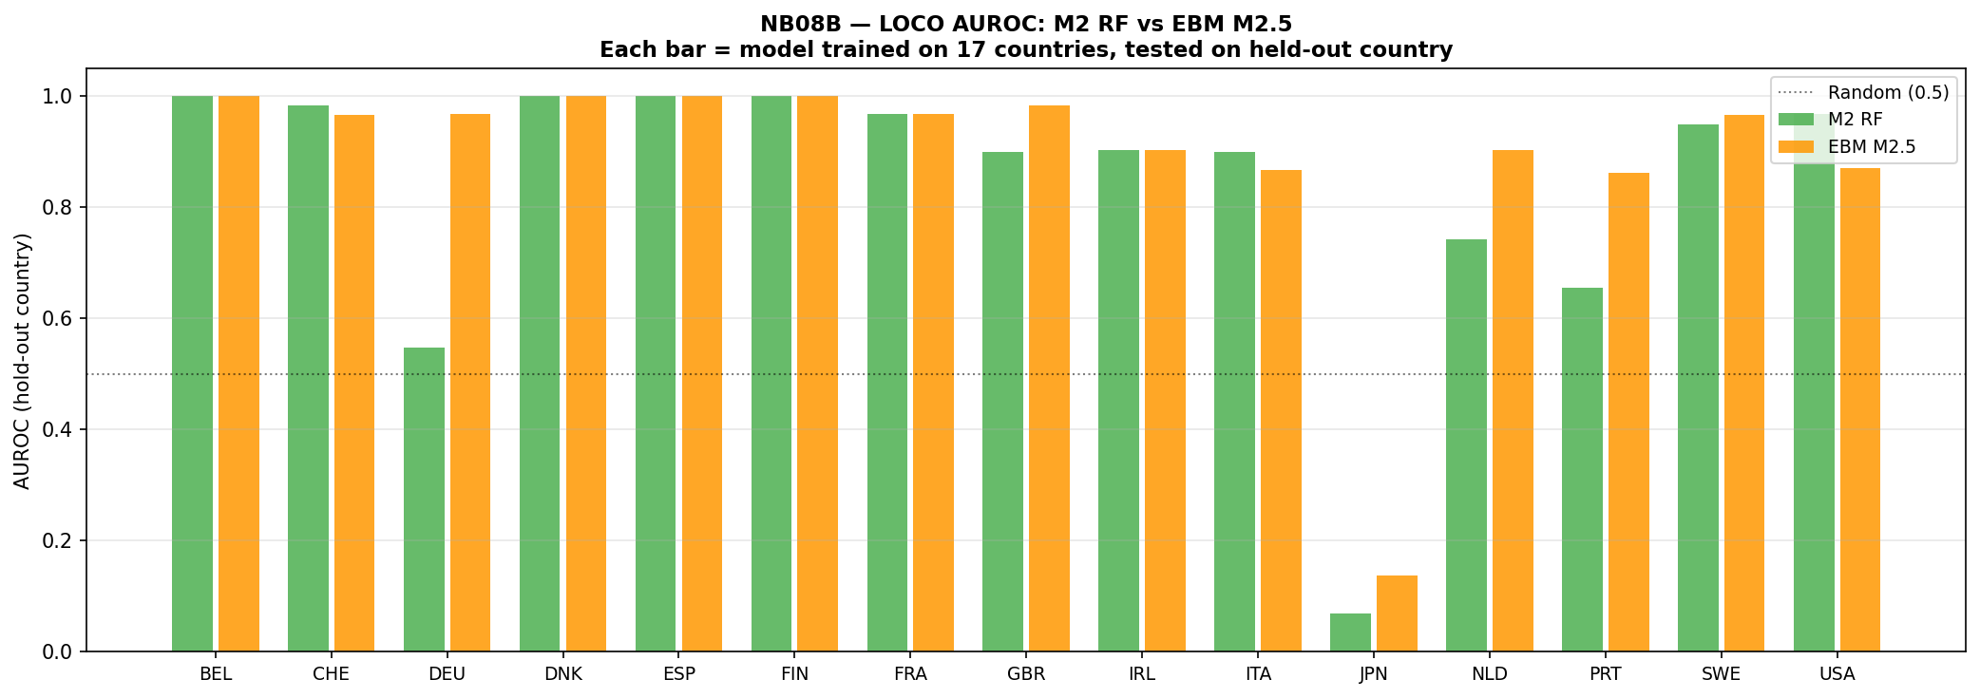
Figure 4.3. Leave-one-country-out AUROC: M2 RF (green) vs EBM M2.5 (orange) for each held-out country, Stage 1 (1988–2020). Each bar represents a model trained on 17 countries, evaluated on the held-out country. Dotted line = random classifier (0.5). AUROC = 1.000 entries reflect trivial single-event ranking.
Table 4.5. Leave-one-country-out summary — M2 RF vs M2.5 EBM, Stage 1
Country | Hold-out events | RF AUROC | EBM AUROC
BEL | 1 | 1.000 | 1.000
CHE | 2 | 0.983 | 0.967
DEU | 1 | 0.548 | 0.968
DNK | 1 | 1.000 | 1.000
ESP | 1 | 1.000 | 1.000
FIN | 1 | 1.000 | 1.000
FRA | 1 | 0.968 | 0.968
GBR | 2 | 0.900 | 0.983
IRL | 1 | 0.903 | 0.903
ITA | 2 | 0.900 | 0.867
JPN | 1 | 0.069 | 0.138
NLD | 1 | 0.742 | 0.903
PRT | 1 | 0.655 | 0.862
SWE | 2 | 0.950 | 0.967
USA | 1 | 0.968 | 0.871
Mean (std) |  | 0.839 (0.254) | 0.893 (0.215)
Table 4.5. AUROC = 1.000 entries reflect trivial single-event ranking. Japan (both models near-random) confirms that asset-deflation dynamics are absent from the training distribution. Mean figures are inflated by single-event results; the cross-sectional pattern reflects sample-specific fitting behaviour rather than stable cross-country generalisation.
EBM shows a higher mean AUROC (0.893 versus 0.839) and lower standard deviation (0.215 versus 0.254) across countries, suggesting more consistent cross-sectional ranking within this evaluation. Country-level differences should be interpreted cautiously, as they reflect sample-specific fitting behaviour rather than stable cross-country predictive structure, and the single-event inflation bias documented in the table footnote prevents strong inference from individual country results.

4.6 SHAP Feature Attribution

4.6.1 Aggregate Attribution by Lag Group
Figure 4.4 presents SHAP attribution for M3 in Stage 2 decomposed by lag group. The total macro share is 73.8 per cent and the FinBERT sentiment share is 26.2 per cent.
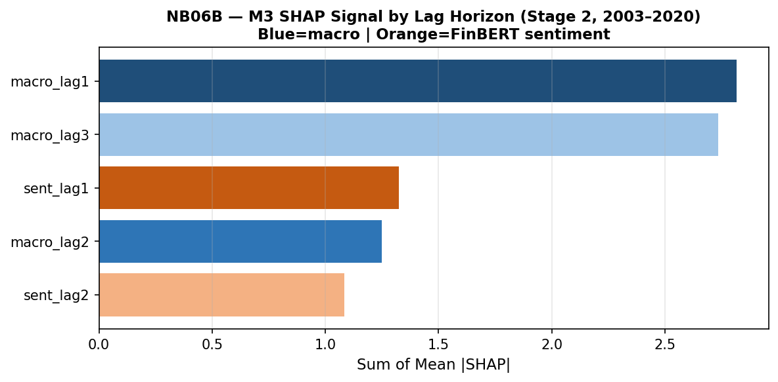
Figure 4.4. M3 SHAP signal by lag horizon (Stage 2, 2003–2020). Dark blue = macro lag1 (2.816); light blue = macro lag3 (2.735); medium blue = macro lag2 (1.249); orange tones = FinBERT sentiment lag1 (1.325) and lag2 (1.083). Macro features account for 73.8% of total attribution; sentiment 26.2%.
The increase from 14.1 per cent sentiment share in the original analysis to 26.2 per cent reflects model re-weighting under a different sample configuration, not evidence of increased economic importance of sentiment. Within the macro group, lag-one features carry the highest aggregate attribution (2.816), marginally ahead of lag-three (2.735) and substantially ahead of lag-two (1.249). SHAP attribution from a single GFC episode cannot be treated as stable or generalisable.

4.6.2 Individual Feature Rankings
The top-20 SHAP feature ranking places the three-year lagged term spread (term_spread_lag3_dm) first by a substantial margin, consistent with the original analysis. The one-year lagged term spread ranks second and the four-year slope of credit growth (tloans_slope4_lag1_dm) ranks third. Five sentiment features appear in the top 20, illustrating the compositional instability of SHAP rankings under single-episode evaluation.
H2 — Feature relevance: Not supported in its strict formulation. No sentiment feature ranks in the top five. Weakly and conditionally observed in a broader sense: five sentiment features appear in the top 20 and sentiment accounts for 26.2 per cent of aggregate SHAP attribution. Rankings are unstable across specifications and all statistical tests in Section 4.9 are non-significant.

4.6.3 Convergence with EBM Native Importance
Figure 4.5 presents SHAP feature rankings for M3 alongside EBM native feature importance for M2.5, derived without post-hoc attribution.
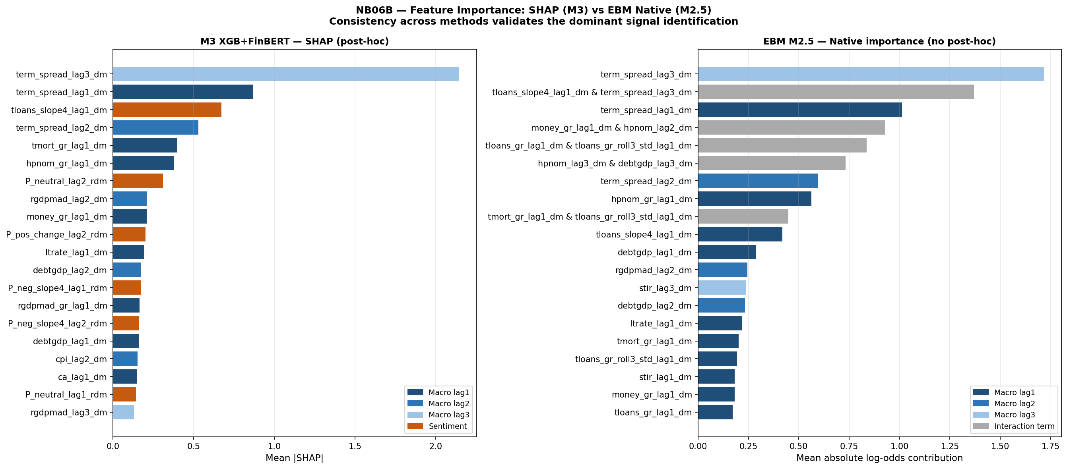
Figure 4.5. Feature importance comparison: M3 SHAP (left, post-hoc) vs EBM M2.5 native importance (right, no post-hoc). Dark blue = lag1; medium blue = lag2; light blue = lag3; orange = sentiment (SHAP only); grey = interaction term (EBM only). Both methods independently identify term_spread_lag3_dm as the dominant feature.
Both methods independently identify term_spread_lag3_dm as the top feature — SHAP assigns it a mean |SHAP| of approximately 2.2, EBM assigns native importance 1.717. This agreement constitutes methodological triangulation: the finding is not an artefact of either the model class or the attribution tool. However, agreement between SHAP and EBM does not validate the causal interpretation of the feature importance. Rather, it indicates that both methods are capturing the same sample-specific correlation structure — one that may be particular to the GFC episode — rather than a stable economic relationship generalisable across crisis regimes. EBM additionally surfaces pairwise interaction terms: the interaction between credit growth trajectory and the three-year lagged term spread ranks second by EBM importance (1.370), making explicit a joint signal that M2 and M3 capture implicitly through their decision structures.

4.7 EBM Interpretability Benchmark

4.7.1 Motivation and Design
M2.5 (EBM) is introduced between M2 and M3 in the model sequence to address a specific limitation: both M2 and M3’s feature-risk relationships are accessible only through post-hoc attribution tools such as SHAP, which are approximate, non-causal, and unstable under sample variation (Lundberg and Lee, 2017; Hooker and Mentch, 2019). EBM fits shape functions that are the model itself — no post-hoc approximation is introduced between the fitted parameters and the interpretability output. This property is essential for the test conducted in Section 4.7.3: if shape function instability is observed in EBM, it cannot be attributed to approximation error in a post-hoc tool. It must reflect a property of the data-generating process itself.

4.7.2 Feature Importance
Figure 4.6 presents EBM’s global feature importance for the Stage 2 full-data fit.
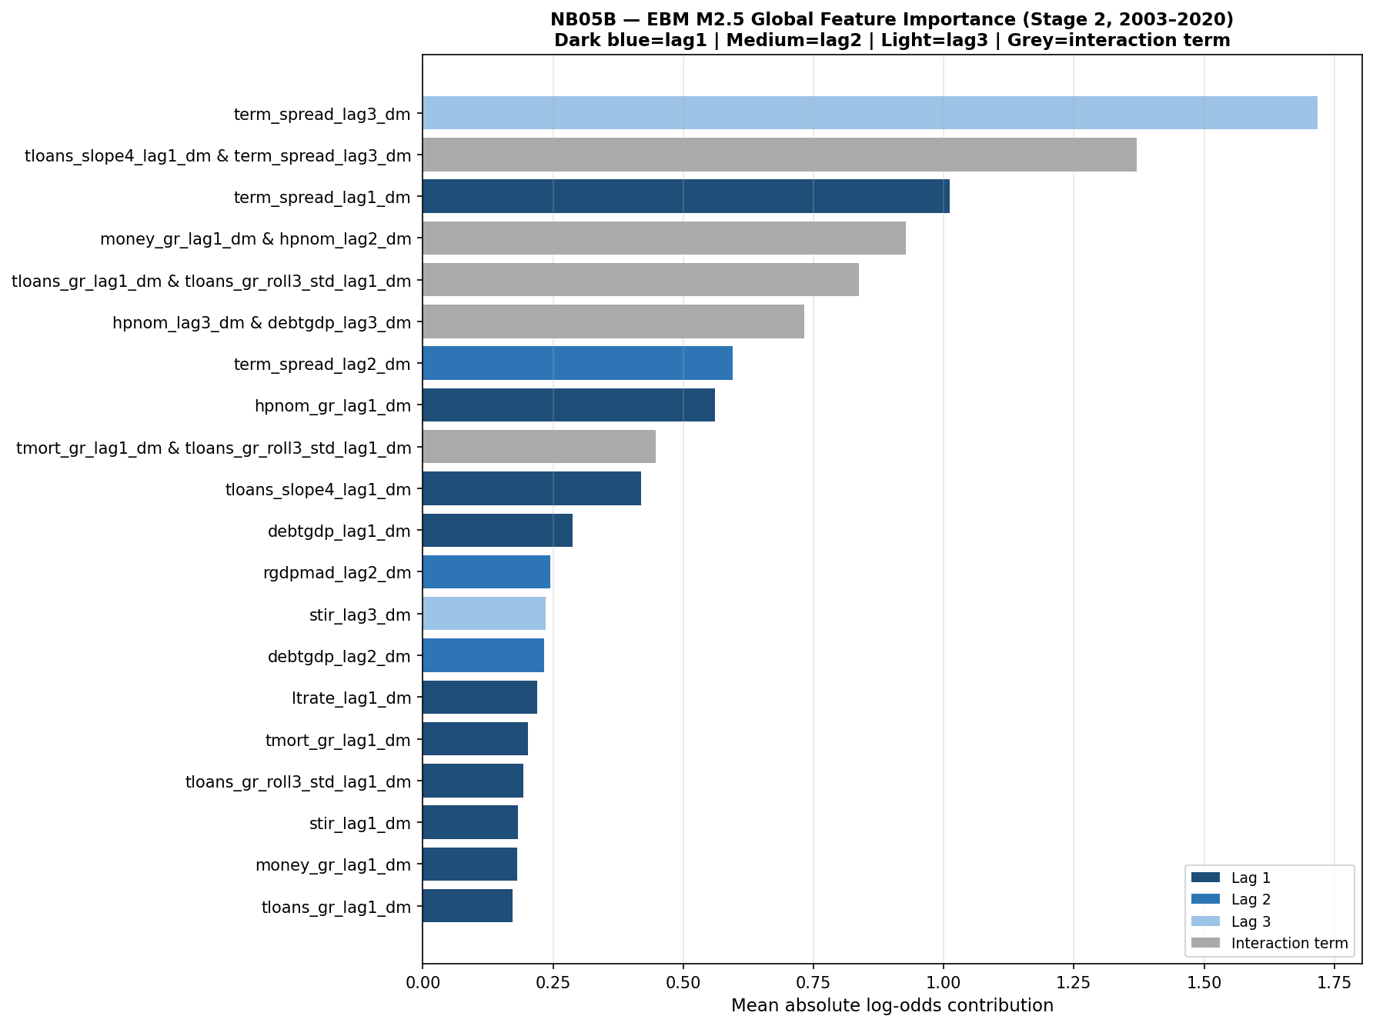
Figure 4.6. EBM M2.5 global feature importance (Stage 2, 2003–2020). Dark blue = lag1; medium blue = lag2; light blue = lag3; grey = interaction term. Term spread at lag 3 (importance 1.717) leads substantially. Term spread appears at all three lag horizons in the top seven features. Signal is concentrated in a small number of economically coherent macro predictors; no sentiment feature appears in the top 20.
EBM’s top five main-effect features are entirely composed of term spread and housing price variables, with term spread at lag three (importance 1.717) leading by a margin of 0.706 over lag one (1.012). The interaction between credit growth trajectory and the three-year lagged term spread ranks second overall (1.370). XGBoost median importance pruning of M3 reduced the feature set from 61 to 31 variables, with removed features concentrated in lower-ranked sentiment and macro-lag-two variables; held-out evaluation was not feasible given insufficient crisis events in the 2016–2020 test window.

4.7.3 Shape Function Analysis: Regime Instability
Figure 4.7 presents EBM shape functions for term spread and total credit across all three lag horizons, estimated separately on a pre-GFC window (2003–2006) and a GFC-inclusive window (2003–2010). This is the centrepiece analysis of the EBM contribution.
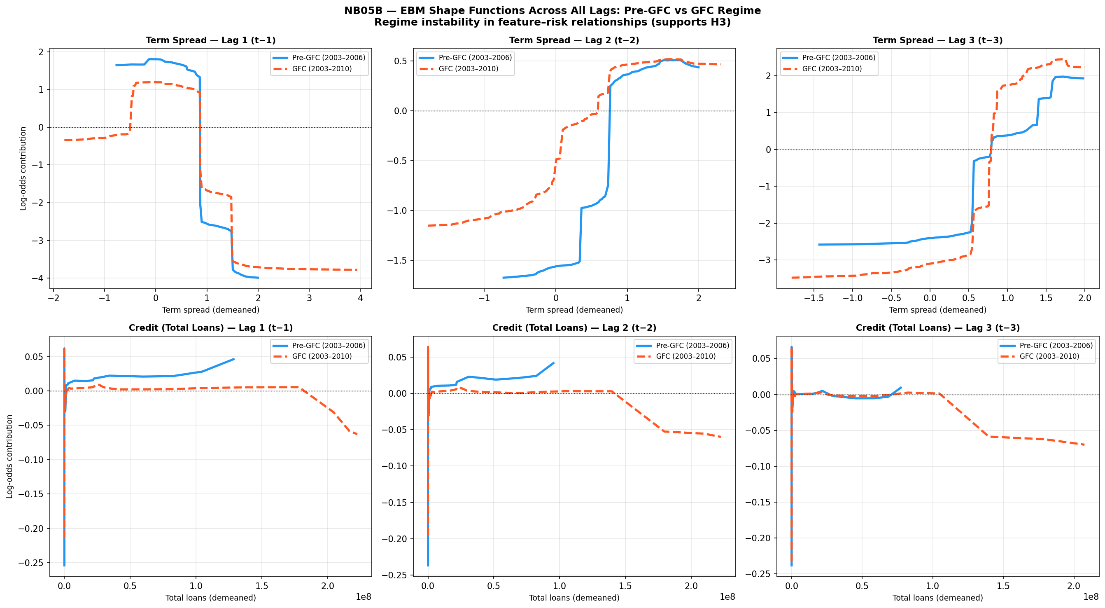
Figure 4.7. EBM shape functions across all lags: Pre-GFC (blue solid, 2003–2006) vs GFC-inclusive (red dashed, 2003–2010). Top row: term spread at lags 1, 2 and 3. Bottom row: total credit at lags 1, 2 and 3. Y-axis: log-odds contribution to crisis probability. Divergence between curves indicates regime-dependent instability in the learned feature-risk mapping. The lag-3 term spread panel (top right) shows qualitatively distinct shapes — not merely scaled versions — confirming structural instability in EBM’s highest-ranked feature.
The instability of EBM shape functions implies that the mapping from macro-financial indicators to crisis risk is not invariant across time, violating the core assumption underlying early-warning systems. Because EBM requires no post-hoc attribution, this instability is a direct property of the fitted model — it cannot be attributed to approximation error in a SHAP calculation or similar tool.
For term spread at lag one, both models produce broadly similar inverted-U patterns but with substantially different magnitudes and transition points: the pre-GFC peak reaches approximately +1.75 log-odds units against the GFC model’s +1.25, and the danger zone threshold shifts leftward once crisis data is included. At lag two, the divergence increases further, with the pre-GFC model producing a sharper shape and the GFC model a more gradual slope. At lag three — the highest-ranked EBM feature (importance 1.717) — the instability is most pronounced and qualitatively distinct: the pre-GFC and GFC shape functions have different structures, not merely different scales. The pre-GFC model learns a monotonically increasing risk relationship at positive spread values, consistent with the theoretical prior that yield curve steepening during credit expansion signals accumulating risk. The GFC-inclusive model partially inverts this at negative spread values, with the two curves crossing — the same feature value is associated with reduced risk in one regime and increased risk in the other. For total credit, the pattern is consistent across all three lags: near-zero pre-GFC contributions (no crisis events from which to identify a credit-crisis association) against increasingly negative GFC-inclusive contributions at high credit values (a compression artefact from countries that peaked before the crisis onset window).
These shape plots make visible the mechanism behind the prospective AUROC collapse in Section 4.5: EBM trained on pre-GFC data learns the blue-line relationships; when evaluated on GFC observations, it applies those pre-GFC mappings to a structurally different environment, producing systematic errors that drive AUROC below random. The shape function analysis converts what would otherwise be an opaque model failure into a legible, regime-specific misspecification — which is precisely the contribution that native interpretability makes possible.

4.8 Calibration Analysis
Figure 4.8 presents the calibration reliability diagrams for all three Stage 2 models.
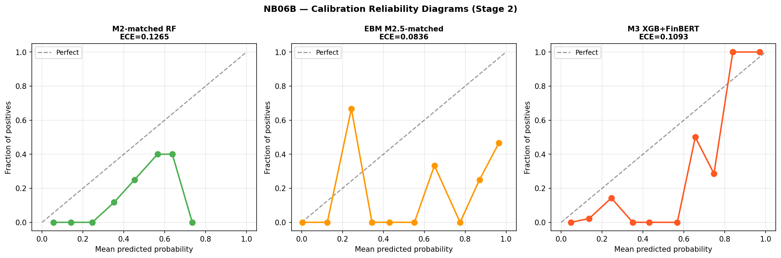
Figure 4.8. Calibration reliability diagrams for Stage 2 models. Left: M2-matched RF (ECE = 0.127). Centre: EBM M2.5-matched (ECE = 0.084). Right: M3 XGB+FinBERT (ECE = 0.109). Dashed diagonal = perfect calibration. Points represent probability bin midpoints vs observed crisis fraction. The noisy appearance reflects 26 crisis events rather than systematic model failure.
Expected Calibration Error for Stage 2 models is 0.127 (M2-matched), 0.084 (M2.5-matched), and 0.109 (M3). EBM appears to achieve the lowest ECE without post-hoc isotonic calibration, in contrast to M3 which applies CalibratedClassifierCV within each fold. Brier Scores are 0.060 (M2-matched), 0.067 (M2.5-matched), and 0.061 (M3). The divergence between EBM’s best ECE and its higher Brier Score reflects the distinction between local calibration and global probability accuracy: ECE rewards smooth probability distributions that align with the empirical crisis rate at the bin level, while Brier Score measures overall squared probability error, which M3’s isotonic calibration directly minimises. EBM produces better-aligned bin-level distributions (lower ECE) without the global squared-error optimisation that isotonic calibration provides (higher Brier). Given 26 crisis events and a single-episode evaluation, neither result is informative about prospective calibration reliability.

4.9 Auxiliary Statistical Tests

4.9.1 Granger Causality: Credit Growth
Granger causality tests for credit growth on the extended Stage 1 panel (1988–2020) find 8 of 42 country-lag combinations significant at 5 per cent — approximately 19 per cent of tests, modestly above the 5 per cent null rate. Belgium shows significance at all three lags; France and the United States at lags two and three; Spain at lag one. Four countries with constant crisis indicators were excluded. These results are directionally consistent with credit-boom dynamics preceding crisis in a minority of countries but do not constitute evidence of a universal or structurally stable predictive channel.

4.9.2 Granger Causality: Term Spread
Granger causality analysis for term spread across 14 countries finds 8 of 42 country-lag combinations significant at 5 per cent overall. At lag three specifically — the EBM dominant lag — 5 of 14 countries are significant: the United Kingdom (p = 0.0016), the Netherlands (p = 0.0028), Italy (p = 0.0092), Japan (p = 0.0151), and Germany (p = 0.0305). EBM’s native importance ranking and country-level Granger F-tests are independent analytical frameworks; both identify the three-year lagged term spread as carrying a distinctive signal. This convergence does not establish causality, and the shape function instability in Section 4.7 demonstrates directly that this statistical relationship is not invariant across regimes.

4.9.3 Panel Logistic: Term Spread
Panel logistic estimation using term spread at all three lag horizons produces a pseudo-R² of 0.135 and a statistically significant likelihood ratio (p < 0.001). The estimated coefficients exhibit a sign reversal across lags: term_spread_lag1_dm carries a negative and significant coefficient (β = −0.646, p = 0.004), while term_spread_lag3_dm carries a positive and significant coefficient (β = +0.630, p = 0.003). This non-monotonic lag structure provides parametric confirmation of the non-linearity identified by EBM’s shape functions: the relationship between term spread and crisis probability changes sign across the lag horizon, and any model that treats this relationship as monotonic is misspecified.

4.9.4 Panel Logistic: Sentiment
Panel logistic on Stage 2 data produces a pseudo-R² of 0.119 for the macro-only specification and 0.153 with sentiment, an increment of 0.034. The P_neg_lag1 coefficient is negative (−6.908) and not significant (p = 0.103). The pseudo-R² increment is treated as directional evidence only.

4.9.5 ML Discrimination vs Statistical Tests
The divergence between ML-based discrimination patterns and the consistent absence of statistical significance across auxiliary tests is the most informative result of this section. Machine learning models show directional AUPRC differentiation; Granger tests, panel logistic, and both attribution methods fail to detect a stable underlying relationship. This divergence highlights the distinction between predictive pattern recognition within a sample and causal economic inference — and explains why models achieve high expanding-window discrimination while failing under genuine prospective evaluation.

4.10 EBM Ensemble Extension

4.10.1 Design and Primary Results
Following Holopainen and Sarlin (2017), an EBM-based ensemble is constructed as E1-EBM = 0.5 · P(M2-matched) + 0.5 · P(M2.5-matched) using equal weights throughout. Figure 4.9 presents the ROC and PR curves for all ensemble variants.
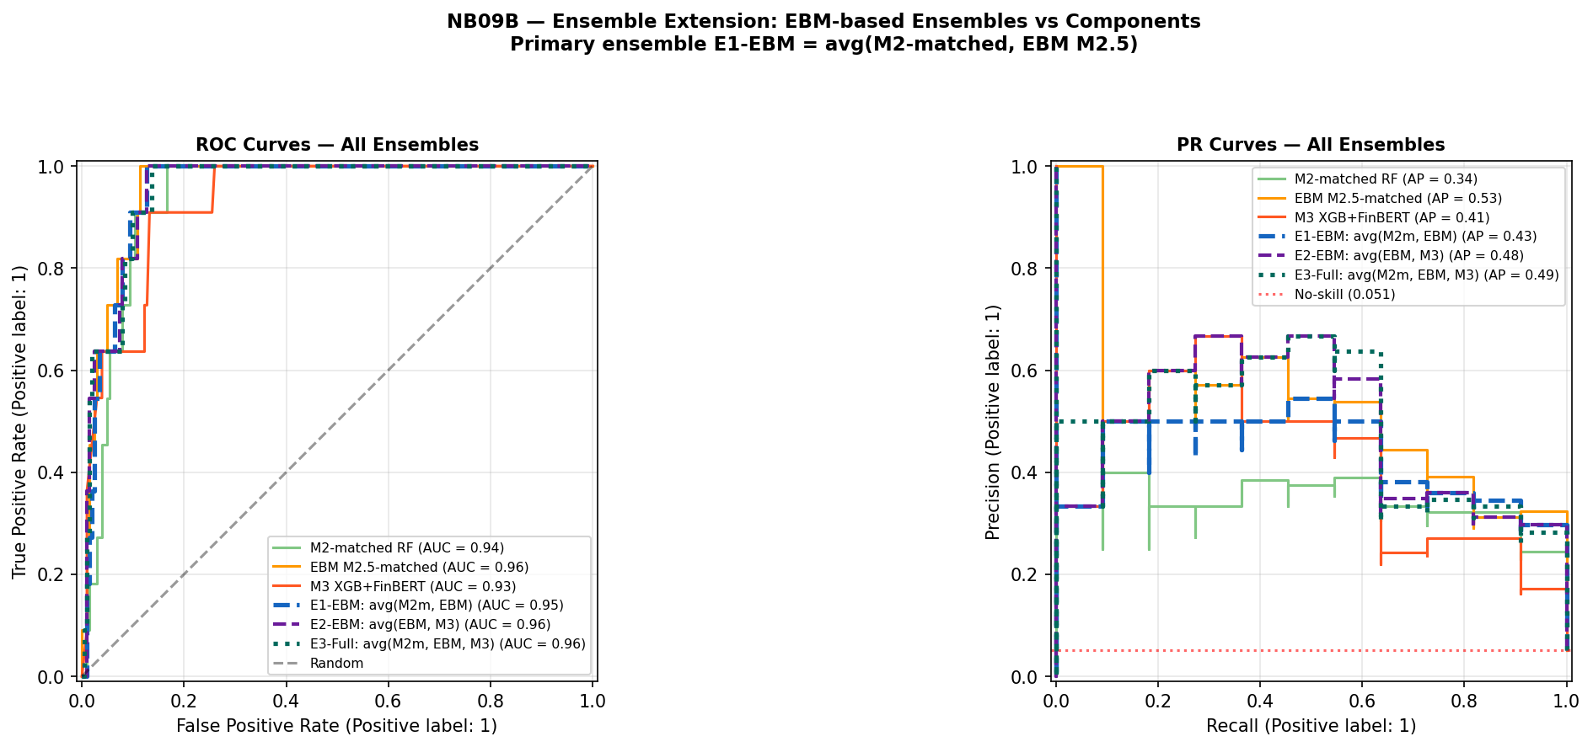
Figure 4.9. Ensemble extension ROC and PR curves (Stage 2 inner-merged OOS, 11 crisis events, base rate 5.1%). Green solid = M2-matched RF; orange solid = EBM M2.5-matched; red solid = M3 XGB+FinBERT; blue dashed = E1-EBM avg(M2m, EBM); purple dashed = E2-EBM avg(EBM, M3); teal dotted = E3-Full avg(M2m, EBM, M3). Red dotted = no-skill baseline. PR curves show that EBM alone (orange) leads on AUPRC; ensemble averaging with lower-AUPRC components reduces the combined AUPRC below EBM’s individual level.
Table 4.6 presents the primary comparison. Metrics are computed on the inner-merged OOS sample (215 observations, 11 crisis events, base rate 5.12 per cent); absolute AUPRC levels are not directly comparable to Tables 4.1–4.2 due to the different crisis event count.
Table 4.6. EBM ensemble results — Stage 2 (inner-merged OOS, 11 crisis events)
Model | AUROC | 95% CI | AUPRC | Brier
M2-matched RF | 0.939 | [0.894, 0.971] | 0.343 | 0.060
M2.5-matched EBM | 0.960 | [0.924, 0.986] | 0.532 | 0.067
M3 XGB+FinBERT | 0.932 | [0.869, 0.979] | 0.411 | 0.061
E1-EBM: avg(M2-matched, EBM) | 0.955 | [0.918, 0.982] | 0.433 | 0.056
E1-Orig: avg(M2m, M3) [M4 ref] | 0.943 | [0.895, 0.979] | 0.440 | 0.057
Table 4.6. E1-Orig corresponds to M4 in Table 4.2. Subject to the evaluation constraints of Section 4.1. E1-EBM improves AUROC (+0.012) and Brier (−0.001) over M4 but is marginally lower on AUPRC (−0.007), reflecting the structural drag of averaging EBM (AUPRC 0.532) with M2-matched (AUPRC 0.343).
E1-EBM achieves AUROC 0.955 and Brier Score 0.056 — the best calibration of any configuration in Table 4.6 — but AUPRC falls to 0.433 from EBM’s standalone 0.532, as averaging with M2-matched (AUPRC 0.343) pulls the combined result below EBM’s individual level.

4.10.2 Disagreement Analysis
Figure 4.10 presents the model disagreement analysis for all three model pairs.
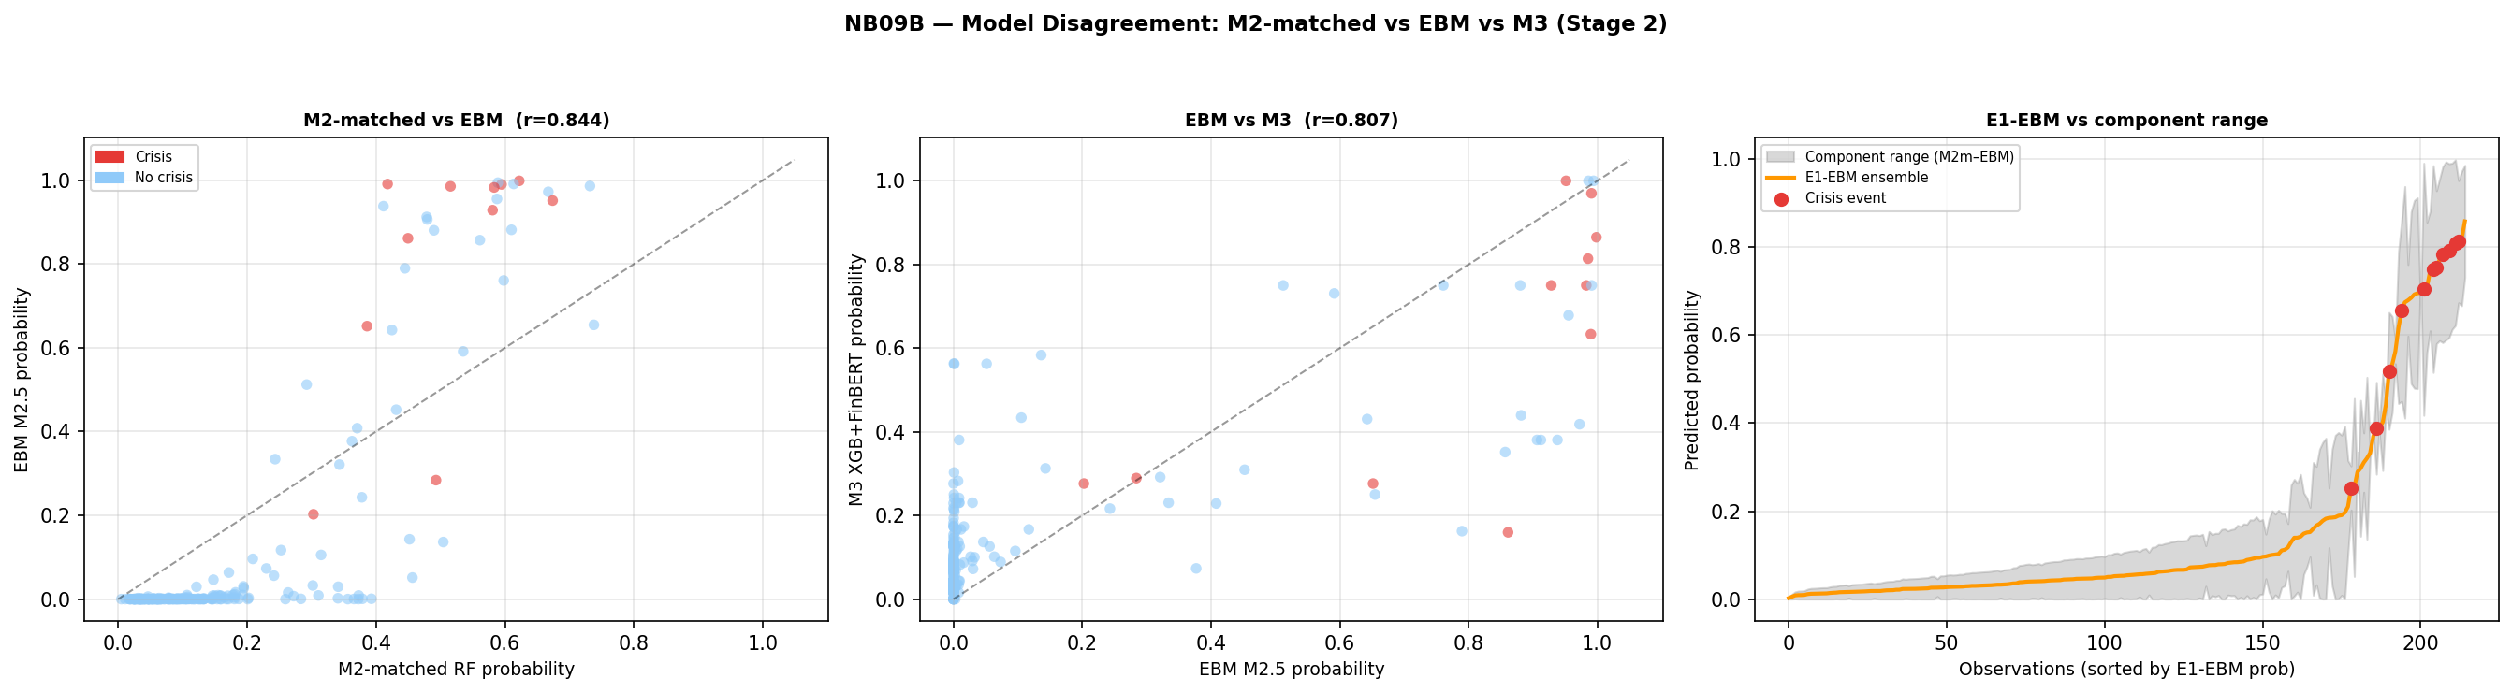
Figure 4.10. Model disagreement analysis (Stage 2). Left: M2-matched RF vs EBM M2.5 probabilities (Pearson r = 0.844); crisis observations in red. Centre: EBM M2.5 vs M3 XGB+FinBERT (r = 0.807). Right: E1-EBM ensemble probability vs M2-matched/EBM component range (grey shading); red dots = crisis events sorted by E1-EBM probability. Crisis observations show substantially higher disagreement than non-crisis observations across all pairs, consistent with the Holopainen and Sarlin (2017) motivation.
Mean absolute disagreement between M2-matched and EBM is 0.348 at crisis observations versus 0.125 at non-crisis observations — a ratio of 2.8:1. This pattern is consistent with the Holopainen and Sarlin (2017) motivation: ensemble averaging is most valuable precisely where individual model uncertainty is highest, which in this dataset corresponds to actual crisis events. The Pearson correlation of 0.844 indicates substantial shared signal alongside meaningful complementarity.

4.10.3 2007 Cross-Sectional Ranking
Figure 4.11 presents the E1-EBM 2007 country ranking by crisis type.
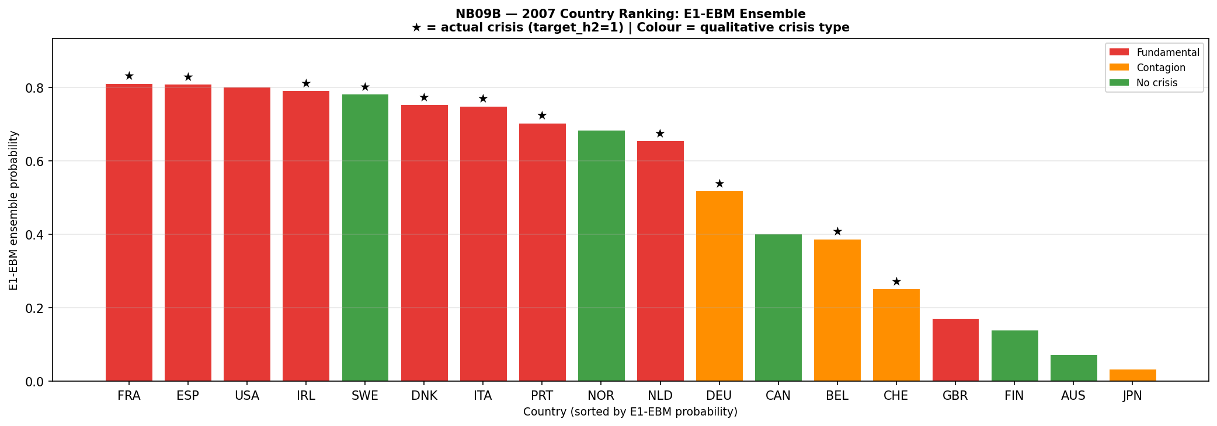
Figure 4.11. 2007 country probability ranking under E1-EBM ensemble, sorted descending. Red = Fundamental crisis; orange = Contagion; green = No crisis. Stars (★) indicate target_h2 = 1 (crisis onset within two years of 2007). Mean E1-EBM by type: Fundamental 0.695 (n=9), No crisis 0.417 (n=5), Contagion 0.298 (n=4). The ordering Fundamental > No crisis > Contagion reflects the model’s training on domestic macro credit-cycle precursors.
Countries experiencing fundamental credit-boom crises receive a mean E1-EBM probability of 0.695, compared with 0.298 for contagion-driven cases and 0.417 for countries with no systemic event. The model correctly discriminates crisis mechanism within the 2007 cross-section: macro precursor-based models assign higher probabilities to crises driven by domestic credit dynamics than to those driven by cross-border contagion or exogenous shocks. Two notable exceptions — Sweden (high probability, no crisis) and the United Kingdom (low probability, fundamental crisis) — illustrate the scope conditions of the macro precursor approach rather than model failure in a general sense. Subject to the evaluation constraints of Section 4.1, this cross-sectional pattern characterises model behaviour within the GFC episode and reflects the scope conditions of the macro precursor approach rather than a generalisable discrimination capability by crisis type.

4.11 Hypothesis Assessment
Table 4.7. Hypothesis assessment under the augmented two-stage pipeline with EBM extension
Hypothesis | Stated prediction | Key evidence | Verdict
H1: Discrimination | M3 achieves higher AUROC/AUPRC than macro-only benchmark | Stage 2: M3 AUPRC 0.411 > M2-matched 0.343 within GFC cross-section. M2.5 EBM appears to achieve AUPRC 0.532 without sentiment, indicating algorithm non-linearity drives Stage 2 performance differences more than the sentiment signal. CI [−0.130, +0.312] spans zero. | Supported directionally on AUPRC within a single-episode evaluation. EBM result indicates discrimination gains are driven by algorithm choice more than sentiment signal. Not statistically confirmed.
H2: Feature relevance | At least one FinBERT feature ranks top-5 by SHAP | 5 sentiment features in top 20; SHAP share 26.2%. EBM native importance corroborates macro dominance independently. Agreement between methods reflects shared sample-specific correlation structure, not causal evidence. All statistical tests non-significant. | Not supported in strict formulation. Weakly and conditionally observed. Two independent attribution methods converge on macro dominance within the GFC sample.
H3: Interpretability trade-off | Quantifiable accuracy-interpretability trade-off across M1–M2–M3 | M1→M2: AUPRC +0.085 at H2 with loss of log-odds transparency. M2→M2.5: within expanding-window evaluation, interpretable EBM appears to achieve higher point estimates than black-box RF. EBM collapses more severely under prospective validation (AUROC 0.333 vs RF 0.481), demonstrating that interpretability does not confer prospective robustness and may increase vulnerability to regime-specific overfitting. | Supported and refined. Trade-off is not binary within the non-linear model class under expanding-window evaluation. This refinement does not alter the central conclusion: neither interpretability nor algorithm choice resolves the regime instability problem.
Table 4.7. Hypothesis assessment under the augmented two-stage pipeline (NB01A–NB09B). AUPRC at H2 is the primary metric. All Stage 2 verdicts reflect cross-sectional discrimination within the GFC episode only. Final revision: April 2026.
The three hypotheses together trace a coherent argument about the structural limits of machine learning-based crisis prediction. H1 is directionally supported but the EBM result clarifies that Stage 2 performance differences reflect algorithm non-linearity more than a stable sentiment signal. H2 fails in its strict formulation, with both SHAP and EBM independently confirming macro dominance — but their agreement reflects shared sample structure rather than causal validation. H3 is supported but requires the qualification introduced by EBM’s prospective collapse: the interpretability-accuracy trade-off is not binary within the non-linear model class under in-sample evaluation, but interpretable models offer no immunity to regime non-stationarity and may encode regime-specific relationships more precisely, increasing their vulnerability under structural breaks.
Taken together, these results indicate that the central limitation of early-warning systems is not predictive capacity within a given sample, but the absence of a stable mapping between predictors and crisis outcomes across regimes — a limitation that cannot be resolved through additional data, model complexity, or interpretability enhancements. This implies that early-warning systems are not merely empirically limited, but conceptually misaligned with environments characterised by structural breaks, where the underlying data-generating process evolves faster than any static model can adapt. In this sense, the failure of machine learning-based early-warning systems reflects a broader limitation of predictive modelling under distribution shift, where models trained on historical data cannot reliably extrapolate to future states drawn from a different underlying process.

Chapter 5: Discussion
Economic Crisis Prediction: Improving the Trade-off Between Interpretability and Statistical Accuracy in ML-Enhanced Crisis Prediction Models
Pavlos Papachristos • PP24589 • MSc Artificial Intelligence, University of Essex Online • April 2026

5.1 Overview of Findings
This chapter synthesises the results in Chapter 4, situates them in the EWS literature, and draws implications for research design and practice. Five interlocking findings define the contribution of the augmented analysis.
The first is that extending macro training history does not resolve the EWS generalisation problem. M2 achieves AUROC 0.481 in Split B strict temporal validation — below random — indicating systematic failure under prospective evaluation. Neither fifteen additional years of crisis history nor greater algorithmic sophistication closes the gap. The second finding concerns sentiment augmentation: within the Stage 2 cross-sectional evaluation, M3 achieves AUPRC 0.411 against M2-matched’s 0.343, a directional gain of 6.8 percentage points, but the bootstrap 95% CI spans zero, all auxiliary statistical tests are non-significant, and EBM achieves higher AUPRC (0.532) without any sentiment features. The third finding is the most theoretically significant: EBM’s shape functions — estimated on disjoint sub-periods — are qualitatively distinct across regimes at every lag horizon, making the learned feature-risk instability directly visible without post-hoc approximation. The fourth is that EBM collapses more severely than RF under prospective evaluation (AUROC 0.333 versus 0.481), demonstrating that higher representational flexibility exacerbates regime-specific overfitting even in natively interpretable models. The fifth is that E1-EBM achieves the best ensemble calibration (Brier 0.056), with disagreement 2.8 times higher at crisis than non-crisis observations, consistent with Holopainen and Sarlin (2017).
Taken together, these findings demonstrate that the failure of early-warning systems is not primarily a function of model choice, feature design, or data availability, but of a deeper structural instability in the mapping between predictors and crisis outcomes across regimes.

5.2 What EBM Reveals About the Failure Mechanism
Because EBM’s shape functions are the model itself rather than post-hoc approximations, the instability observed when fitting on disjoint sub-periods must reflect a property of the data-generating process. For term spread at lag three — the highest-ranked feature (native importance 1.717) — the pre-GFC and GFC-inclusive shape functions are structurally distinct and cross: the same feature value is associated with reduced risk under one regime-specific model and increased risk under the other. For credit features, the pre-GFC model assigns near-zero contributions while the GFC-inclusive model assigns increasingly negative contributions at high credit values.
This instability implies that the mapping from macro-financial indicators to crisis risk is not invariant across time, violating the core EWS assumption. This places crisis prediction within the broader class of non-stationary learning problems, where models trained under one data distribution cannot be expected to generalise when the underlying process evolves. Early-warning systems are not merely empirically limited — they are conceptually misaligned with structural break environments where the data-generating process evolves faster than any static model can adapt.
The convergence of SHAP attribution (M3) and EBM native importance on term_spread_lag3_dm as the dominant signal reflects shared sample-specific correlation structure rather than causal invariance. The Granger confirmation (5 of 14 countries significant at lag three) and the logistic sign reversal (lag1 β = −0.646, p = 0.004; lag3 β = +0.630, p = 0.003) provide independent parametric support for a non-monotonic lag structure that EBM’s shape functions make directly visible.

5.3 Crisis Heterogeneity and Ensemble Results
The 2007 cross-sectional ranking under E1-EBM demonstrates mechanism-specific discrimination: fundamental crisis countries receive mean probability 0.695, contagion-driven cases 0.298, and no-crisis countries 0.417. Macro precursor features carry more signal for domestically generated credit-boom dynamics than for externally transmitted stress — explaining the false negative for the United Kingdom (GBR probability 0.171; funding-channel stress not captured by domestic credit features) and the false positive for Sweden (probability 0.783; genuine macro expansion without systemic crisis due to institutional buffers).
The E1-EBM ensemble achieves Brier Score 0.056 — best of any Stage 2 configuration — while AUPRC falls to 0.433 from EBM’s standalone 0.532, as averaging with M2-matched (AUPRC 0.343) pulls the combined result down. The ensemble gain is concentrated in calibration. All results are subject to the single-episode evaluation constraint of Section 4.1.

5.4 Implications for EWS Design
Four practical implications follow. First, prospective validation across crisis regimes must be a mandatory evaluation step — expanding-window metrics substantially overstate forward-looking performance when the evaluation dataset is dominated by a single episode. Second, interpretable non-linear models such as EBM should be adopted for EWS applications not primarily for their in-sample metrics but for their diagnostic capability: shape functions allow practitioners to detect when the model’s learned mapping no longer reflects the current regime. Third, ensemble averaging should be preferred over single-model outputs for operational probability estimates, given its consistent Brier Score advantage. Fourth, sentiment augmentation requires multi-episode validation before operational deployment; the current signal is unstable across specifications and not statistically confirmed.

5.5 Limitations
The dominant constraint is the single-episode evaluation structure: Stage 2 rests on crisis events in a single year — 2007 — across 18 countries, constituting cross-sectional country ranking rather than temporal validation. EBM’s stronger prospective collapse relative to RF confirms that higher representational flexibility can exacerbate regime-specific overfitting; interpretable models should be adopted for transparency value, not prospective superiority. The sentiment corpus has uneven coverage across countries, and bootstrap confidence intervals are indicative only due to panel dependence.

5.6 Future Research
Three extensions, ranked by feasibility: (1) Most feasible — topic-specific text features from the existing BIS corpus following Ho, Moench and Steeley (2022) and Loughran and McDonald (2011), replacing aggregate sentiment polarity with prevalence measures for credit risk discussion. (2) Most impactful — regime-conditional modelling using EBM shape functions as inputs to a clustering algorithm to identify distinct crisis regimes, directly addressing the non-stationarity finding. (3) Most ambitious — network contagion features from BIS consolidated banking statistics (Cetorelli and Goldberg, 2011), allowing the model to distinguish domestic stress from externally transmitted risk.

5.7 Conclusion
The augmented analysis advances the original study on four dimensions: empirically demonstrating that additional training data does not resolve prospective failure; methodologically exposing expanding-window evaluation bias; using EBM to make the regime-specific misspecification directly visible; and theoretically showing that the failure is a structural property of non-stationarity, not model opacity. The failure of machine learning-based early-warning systems reflects a broader limitation of predictive modelling under distribution shift, where models trained on historical data cannot reliably extrapolate to future states drawn from a different underlying process. Progress requires not better models trained on the same framework, but a reconceptualisation of the EWS problem that incorporates regime-awareness as a first-class design principle.

Chapter 5 revision: April 2026

Chapter 6: Conclusions and Recommendations
Economic Crisis Prediction: Improving the Trade-off Between Interpretability and Statistical Accuracy in ML-Enhanced Crisis Prediction Models
Pavlos Papachristos • PP24589 • MSc Artificial Intelligence, University of Essex Online • April 2026

6.1 Summary
This dissertation investigated the conditions under which ML-based early-warning systems for banking crises achieve genuinely prospective predictive performance, and characterised the structural conditions under which their generalisation fails. The central finding is that the failure is structural rather than technical: it reflects non-stationarity in the data-generating process, not a correctable consequence of model choice, feature design, or data availability.

6.2 Principal Conclusions
Conclusion 1: Extended training history does not resolve the generalisation problem. M2 (Random Forest) trained on the 1989–2020 panel achieves AUROC 0.481 in Split B strict temporal validation — below random. Adding fifteen years of diverse crisis history does not produce a model that generalises to the GFC. The regime discontinuity between pre-GFC crisis types and GFC credit-cycle dynamics is too large for aggregate macro features to bridge.
Conclusion 2: The interpretability-accuracy trade-off is not binary within the non-linear class. Within the expanding-window evaluation, EBM achieves higher point estimates than both M2 (Stage 1 AUROC 0.753 vs 0.636) and M3 (Stage 2 AUPRC 0.532 vs 0.411) while providing natively interpretable shape functions. However, EBM’s prospective collapse (AUROC 0.333) is more severe than RF’s (0.481). Greater representational flexibility fits the training regime more precisely, producing worse prospective failure when the regime changes. The trade-off must be understood in regime-conditional terms.
Conclusion 3: EBM shape functions make the failure mechanism directly visible. The pre-GFC and GFC-inclusive shape functions for term_spread_lag3 — the highest-ranked feature — are qualitatively distinct rather than scaled versions of each other, with the two curves crossing. This is a direct observation of data-generating process non-stationarity, not an artefact of an attribution tool. EWS are not merely empirically limited but conceptually misaligned with structural break environments where the DGP evolves faster than any static model can adapt.
Conclusion 4: FinBERT sentiment contributes a directional but unstable signal. M3’s AUPRC gain over M2-matched (6.8 percentage points) has a confidence interval spanning zero, is not confirmed by statistical tests, and is better attributed to algorithm non-linearity than a stable sentiment channel. SHAP and EBM independently confirm macro dominance (73.8% of attribution).
Conclusion 5: Ensemble averaging provides calibration benefits. E1-EBM achieves Brier Score 0.056 — best of any Stage 2 configuration — with disagreement 2.8× higher at crisis than non-crisis observations. The gain is concentrated in calibration rather than AUPRC, as averaging pulls the combined precision-recall below EBM’s individual level.

6.3 Practical Recommendations
R1 — Mandatory prospective validation. Expanding-window metrics must be accompanied by strict temporal validation before any EWS model is characterised as predictively useful. Models that pass the former but fail the latter should not be deployed.
R2 — EBM as a regime stability diagnostic. Interpretable models should be maintained alongside operational black-box models not for their in-sample metrics but for their diagnostic capability: shape functions reveal when the model’s learned mapping no longer applies to the current regime — information with direct regulatory value.
R3 — Ensemble averaging for operational outputs. Equal-weighted ensemble averaging consistently produces better-calibrated probability estimates (lower Brier Score) than any single component model and should be preferred as the operational output mechanism.
R4 — Multi-episode validation before sentiment deployment. The FinBERT sentiment channel requires validation across at least two structurally distinct crisis episodes and confirmation that gains survive algorithm-controlled comparisons before operational deployment.

6.4 MSc AI Contribution
This dissertation satisfies the MSc in Artificial Intelligence requirements through: implementation and critical evaluation of three ML model classes (XGBoost, Random Forest, EBM) and a transformer NLP pipeline (FinBERT); rigorous evaluation methodology including expanding-window CV, bootstrap CIs, Granger causality, SHAP, and EBM shape function analysis; and a theoretical contribution connecting the EWS problem to the ML literature on distribution shift and non-stationary learning. The research uses exclusively publicly available secondary data (ethics clearance: low risk). Code is available at https://github.com/spike2025-art/eportfolio-uoe/tree/main; ePortfolio at https://spike2025-art.github.io/eportfolio-uoe/.

6.5 Future Directions
Three extensions, ranked: (1) Most feasible — topic-specific text features from the existing BIS corpus. (2) Most impactful — regime-conditional modelling using EBM shape functions to identify crisis regimes, directly addressing the non-stationarity finding. (3) Most ambitious — network contagion features from BIS banking statistics following Cetorelli and Goldberg (2011).

6.6 Final Reflection
The most important lesson from this analysis is not about any specific model or feature. It is about the relationship between machine learning and non-stationarity: a model trained on historical data is a representation of the past, and when the process that generated that past changes, the model’s learned representation becomes a misrepresentation. EBM’s contribution is to make this misrepresentation visible — converting an opaque model failure into a legible, regime-specific misspecification. That visibility is not a solution to the non-stationarity problem, but it is a prerequisite for addressing it. The value of interpretable machine learning in high-stakes prediction domains lies not in the accuracy of the models it produces, but in the quality of the understanding it provides.

Chapter 6 revision: April 2026

